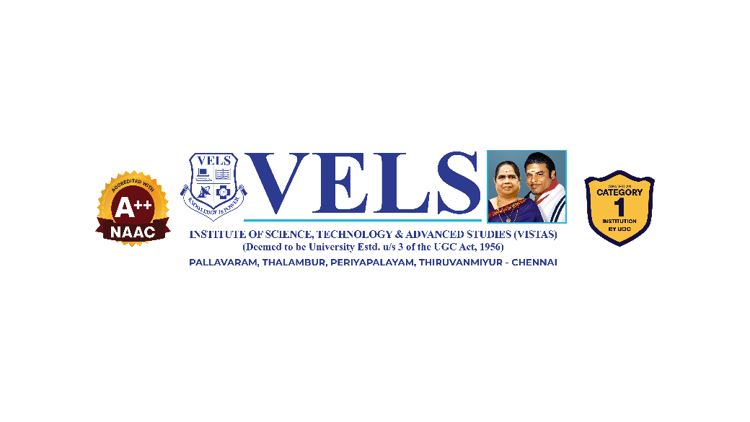
Food Expiry Detection and Reminder System
Abstract
Food waste is a growing global concern, largely driven by consumers forgetting the expiry dates of stored food items. While packaged products carry printed expiry dates, fresh food items such as vegetables and fruits do not, making it difficult for users to track their freshness and safe consumption period. This project proposes an AI-Powered Food Expiry Detection and Reminder System designed to address both categories through a single mobile application. For packaged products, the system uses barcode scanning for product identification and Optical Character Recognition (OCR) to extract manufacturing and expiry dates from product labels. For fresh food items, the system estimates shelf life based on a predefined food-type dataset combined with user-specified storage conditions, with provision for image-based freshness analysis to improve prediction accuracy over time. Users can also manually customize expiry durations based on personal preference. All items are recorded in a centralized inventory that tracks remaining shelf life and issues timely notifications before expiry. By integrating barcode recognition, OCR, and predictive shelf-life estimation into a unified platform, the proposed system aims to reduce food wastage, minimize health risks associated with expired food consumption, and support efficient food inventory management for households and small businesses.

Team members:- Project guide name :-
- Karunya ,S 1. Ms. S.M Sowmiya
- Abarna .V
- Yogalakshmi .M

